CULTURAL ROUTES 2024 – ROME

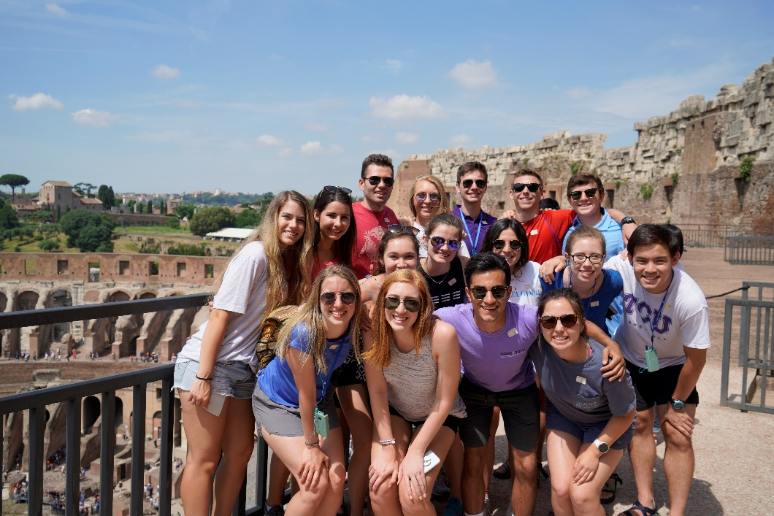

A traveling classroom concentrated on experiential learning . . .
Honors Cultural Routes: Rome will explore the cultures and histories that gave rise to our current understanding of Rome. More specifically, students will explore intensely the eternal city to understand how this unique urban center—sometimes referred to a historical lasagna—was and continues to be shaped by philanthropic acts associated with religious, political, and cultural movements. Students will spend time traveling throughout Rome and interacting with locals. Employing a traveling classroom that privileges experiential learning, this spring-break study will challenge students to extend their understanding of themselves and their capabilities to a more global perspective, one where they regard themselves as part of a larger global narrative and where they begin to imagine the ways in which they can help change the world.

Guiding Questions:
- How has philanthropy shaped Rome, and how does it continue to do so?
- How did systems of sponsorship give birth to cultural, religious, artistic, and health artifacts?
- How did politicians and religious leaders philanthropically shape the Rome we see and experience today?
- How does a city function while hosting a separate sovereign state in its city limits? How does this impact networks of aid and support?
- How can we begin to answer these questions and imagine new ones in the multiple historical and physical layers—ancient to Renaissance to Neo-classical to Fascist—that make up Rome?

Expectations and Additional Information for Honors Abroad: Cultural Routes Rome

First, participating in Cultural Routes on spring break is an honor and a privilege. All students are representing Texas Christian University, the John V. Roach Honors College, their colleagues on the experiences, and their families. This is a high responsibility.

As a result, students are expected to behave in a way that demonstrates utmost respect of the people in Rome, the university, the college, and everyone connected to the experience.

Specific issues:

- This will be an intense, highly-engaging experience that requires a lot of conversation and participation. There will not be much downtime.
- Students will walk all over Rome. Expect to walk a minimum of 10 miles per day; on many days the group will walk a much higher mileage than 10.
- Students should expect late nights (night adventures with the group) and early mornings.
- Students should be prepared to engage Rome through city-as-text pedagogy. This means students should be prepared to engage active learning that helps students regard Rome as a book to be read and to see this spring break experience as a journey of uncovering and discovering a new environment.
- Students will need to be on time for all activities. We will have a packed schedule that embraces the motto “All In: 24-7.”
- Students will participate fully in both planned and spontaneous itineraries, which include site visits, team excursions (both small group and large group), discussions, and meals.
- Students will blog before, during, and after their time in Rome in order to tangibly reflect on their experiences and learning.
- Students will complete individual pre-experience and post-experience meetings with Dr. Pitcock.
- Students will complete and present a Pecha Kucha assignment in Fall 2024 to showcase their learning. In preparation, they will take photographs during their time in Europe and compose written reflections in journals.
- Students will abide by all the policies and procedures surrounding study abroad as detailed by TCU, TCU’s Center for International Studies, and the John V. Roach Honors College.
- Students will not consume ANY alcoholic beverage or illegal substance during Cultural Routes.

